**SSN COLLEGE OF ENGINEERING**

**DEPARTMENT OF COMPUTER SCIENCE AND ENGINEERING**

**UCS1712 – GRAPHICS AND MULTIMEDIA LAB**

**EX NO: 1 – Study of Basic output primitives in OpenGL**

**Name: Nachammai Devi Pooja S RollNo:185001096**

**Date:22/07/2020 Class & Sec: CSE-B**

**1)**

**Aim:**

To Create a window using OPENGL and to draw the following basic output primitives – POINTS, LINES, LINE_STRIP, LINE_LOOP, TRIANGLES, TRIANGLE STRIP, TRIANGLE FAN, QUADS, QUAD_STRIP, POLYGON.

**Algorithm:**

1. Create a Project in visual studio and add flew and glut library to the project.
2. Create a cpp file to type our needed resul.
3. Initialize the colours ,size and name for projection window.
4. Type the code for each of these shapes :- POINTS, LINES, LINE_STRIP, LINE_LOOP, TRIANGLES, TRIANGLE STRIP, TRIANGLE FAN, QUADS, QUAD_STRIP, POLYGON.
5. Define the size and colour of each shape.
6. Display the defined shapes using Display function.
7. Run the code.
8. Get the output from the results window

**Code:**

#include<windows.h>

#include<GL/glut.h>

#include<math.h>

void myInit() {// initialize colors

glClearColor(0.9, 0.8, 0.8, 0.9);

glColor3f(0.0f, 0.0f, 0.0f);

glPointSize(10);

glMatrixMode(GL_PROJECTION);

glLoadIdentity();

gluOrtho2D(0.0, 640.0, 0.0, 480.0);

}

void myDisplay() {

/* clear window */

glClear(GL_COLOR_BUFFER_BIT);

//1.Points:

glBegin(GL_POINTS);

glColor3f(0.1, 0.1, 0.1);

glVertex2d(150, 100);

glVertex2d(100, 230);

glVertex2d(170, 130);

glVertex2d(300, 350);

glEnd();

//2.LINES

glBegin(GL_LINES);

glVertex2d(580, 80);

glVertex2d(500, 80);

glVertex2d(670, 80);

glVertex2d(800, 40);

glEnd();

//3.LINE STRIP

glBegin(GL_LINE_STRIP);

glColor3f(0.1, 0.2, 0.1);

glVertex2d(270, 100);

glVertex2d(100, 230);

glVertex2d(270, 150);

glVertex2d(300, 350);

glEnd();

//4.QUADS : Square

glBegin(GL_QUADS);

glColor3f(0.3, 0.5, 0.6);

glVertex2d(200, 200);

glVertex2d(300, 200);

glVertex2d(300, 300);

glVertex2d(200, 300);

glEnd();

//5.Triangle:

glBegin(GL_TRIANGLES);

glColor3f(0.2, 0.5, 0.4);

glVertex2d(100, 200);

glVertex2d(50, 150);

glVertex2d(150, 150);

glEnd();

//6. MULTIPLE TRIANGLES

glBegin(GL_TRIANGLES);

glColor3f(0.5, 0.5, 0.6);

glVertex2d(350, 90);

glVertex2d(90, 90);

glVertex2d(170, 60);

glVertex2d(100, 100);

glVertex2d(290, 190);

glVertex2d(200, 200);

glEnd();

//7.Quad strip :

glBegin(GL_QUAD_STRIP);

glColor3f(0.1, 0.5, 0.1);

glVertex2d(600, 600);

glVertex2d(750, 600);

glVertex2d(750, 750);

glVertex2d(600, 750);

glVertex2d(350, 350);

glVertex2d(450, 350);

glVertex2d(450, 450);

glVertex2d(350, 450);

glEnd();

//8.polygon:

glBegin(GL_POLYGON);

glColor3f(0.1, 0.5, 0.6);

glVertex2i(230, 350);//Top left

glVertex2i(250, 350);//Top Right

glVertex2i(250, 296);//Bottom Right

glVertex2i(230, 318);//Bottom Left

glEnd();

/*flush GL buffers*/

glFlush();

}

int main(int argc, char* argv[]) {

glutInit(&argc, argv);

glutInitDisplayMode(GLUT_SINGLE | GLUT_RGB);

glutInitWindowSize(1540, 1540);//set window size

glutCreateWindow("primitives");//create window and set title to house

glutDisplayFunc(myDisplay);//call the displaying function

myInit();//call the displaying function

glutMainLoop();//keep displaying until program is closed.

return 1;

}

**Output Screenshot:**

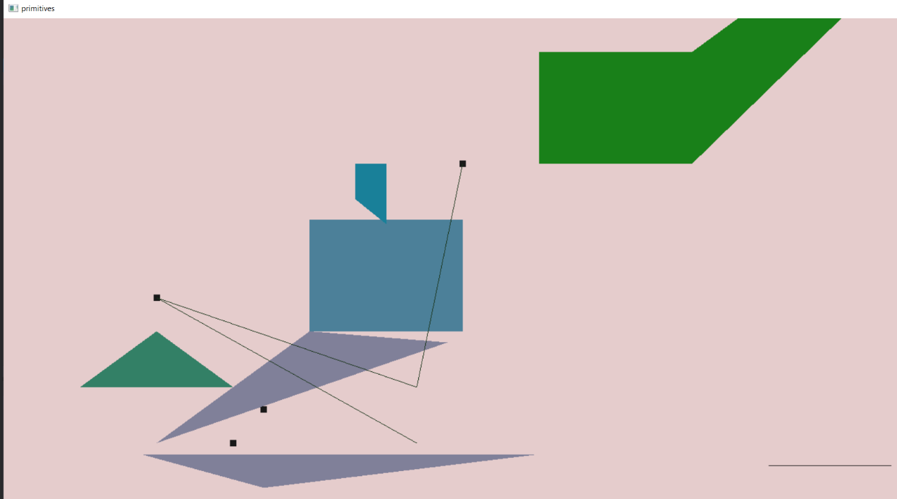

**Result:**

Using OPENGL the basic output primitives – POINTS, LINES, LINE_STRIP, LINE_LOOP, TRIANGLES, TRIANGLE STRIP, TRIANGLE FAN, QUADS, QUAD_STRIP, POLYGON have been created using OpenGL

**2)**

**Aim:**

To Create a window and draw a simple House using OpenGL

**Algorithm:**

1. Create a Project in visual studio and add flew and glut library to the project.
2. Create a cpp file to type our needed resul.
3. Initialize the colours, size and name for projection window.
4. Type the code for each of the shapes involved in creating the house
5. Define the size and colour of each shape.
6. Display the defined shapes using Display function.
7. Run the code.
8. Get the output from the results window

**Code:**

#include<windows.h>

#include<GL/glut.h>

#include<math.h>

void myInit() {// initialize colors

glClearColor(0.0, 0.0, 0.0, 0.0);

glColor3f(0.0f, 0.0f, 0.0f);

glPointSize(10);

glMatrixMode(GL_PROJECTION);

glLoadIdentity();

gluOrtho2D(0.0, 640.0, 0.0, 480.0);

}

void myDisplay() {

/* clear window */

glClear(GL_COLOR_BUFFER_BIT);

//main

glColor3f(0.8, 0.7, 0.4);

glBegin(GL_POLYGON);

glVertex2i(100, 250);//Top left

glVertex2i(270, 250);//Top Right

glVertex2i(270, 100);//Bottom Right

glVertex2i(100, 100);//Bottom Left

glEnd();

//roof

glBegin(GL_TRIANGLES);

glColor3f(0.7, 0.4, 0.1);

glVertex3i(80, 250, 0);

glVertex3i(290, 250, 0);

glVertex3i(185, 370, 0);

glEnd();

//steps

glBegin(GL_POLYGON);

glColor3f(0.1, 0.1, 0.5);

glVertex2i(130, 110);//Top left

glVertex2i(240, 110);//Top Right

glVertex2i(240, 100);//Bottom Right

glVertex2i(130, 100);//Bottom Left

glEnd();

glBegin(GL_POLYGON);

glColor3f(0.1, 0.1, 1);

glVertex2i(130, 120);//Top left

glVertex2i(240, 120);//Top Right

glVertex2i(240, 110);//Bottom Right

glVertex2i(130, 110);//Bottom Left

glEnd();

//door

glBegin(GL_POLYGON);

glColor3f(0.4, 0, 0.2);

glVertex2i(160, 200);//Top left

glVertex2i(210, 200);//Top Right

glVertex2i(210, 120);//Bottom Right

glVertex2i(160, 120);//Bottom Left

glEnd();

//Windows

glBegin(GL_POLYGON);

glColor3f(0.3, 0.4, 0.7);

glVertex2i(110, 210);//Top left

glVertex2i(150, 210);//Top Right

glVertex2i(150, 165);//Bottom Right

glVertex2i(110, 165);//Bottom Left

glEnd();

glBegin(GL_POLYGON);

glColor3f(0.3, 0.4, 0.7);

glVertex2i(220, 210);//Top left

glVertex2i(260, 210);//Top Right

glVertex2i(260, 165);//Bottom Right

glVertex2i(220, 165);//Bottom Left

glEnd();

//chimney

glBegin(GL_POLYGON);

glColor3f(0.3, 0.5, 0.7);

glVertex2i(230, 350);//Top left

glVertex2i(250, 350);//Top Right

glVertex2i(250, 296);//Bottom Right

glVertex2i(230, 318);//Bottom Left

glEnd();

//chimney-top

glBegin(GL_POLYGON);

glColor3f(0.1, 0.1, 0.6);

glVertex2i(260, 370);//Top left

glVertex2i(220, 370);//Top Right

glVertex2i(220, 350);//Bottom Right

glVertex2i(260, 350);//Bottom Left

glEnd();

/*flush GL buffers*/

glFlush();

}

int main(int argc, char* argv[]) {

glutInit(&argc, argv);

glutInitDisplayMode(GLUT_SINGLE | GLUT_RGB);

glutInitWindowSize(1340, 1340);//set window size

glutCreateWindow("House");//create window and set title to house

glutDisplayFunc(myDisplay);//call the displaying function

myInit();//call the displaying function

glutMainLoop();//keep displaying until program is closed.

return 1;

}

**Output Screenshot:**

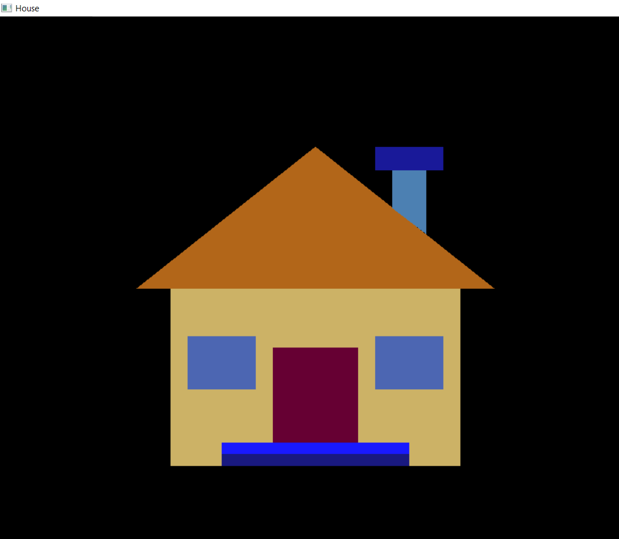

**Result:**

A house with windows, doors, steps and chimney has been created using OpenGL